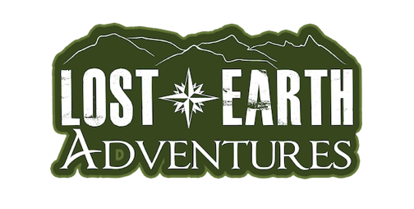
School Name
School Address
Permission Letter
Dear Parent/Guardian,
We have organised an Activity Day/ Residential for Year [insert year group] with Lost Earth Adventures at their activity centre [insert address here]. This school trip will take place from [insert beginning & end date].
During our time with Lost Earth Adventures, we will be taking part in lots of fun outdoor activities, including [insert activities]. The total cost of this Activity Day/Residential will be £ [insert amount] per child.
Payment procedure:
- Your initial deposit will be £ [insert amount] and is due one the [insert due date]
- Your second deposit will be £ [insert amount] and is due one the [insert due date]
- Your final deposit will be £ [insert amount] and is due one the [insert due date]
Please fill in and return the consent form by [insert due date].
Lost Earth Adventures is an award-winning provider with fully qualified instructors. All staff hold DBS checks, and the company operates under a comprehensive Child Protection Policy. Activities are inclusive, ensuring every participant can take part safely and confidently.
Lost Earth Adventures has earned over 1,000 five-star reviews and holds an AALA Licence, the highest accreditation available from the British Government for adventurous activity providers in the UK. The company is also a proud member of Adventuremark, a non-statutory safety scheme managed by the Adventure Activity Industry Advisory Committee (AAIAC) and has achieved the Learning Outside the Classroom (LOtC) Quality Badge, the only nationally recognised award covering both learning and safety for activities outside the scope of AALA.
For more information on Lost Earth Adventures, please visit their website at: https://www.lostearthadventures.co.uk If you have any questions, please do not hesitate to contact me.
Best wishes,
[Insert name]

CONSENT FORM
Please fill out the below information as accurately as possible.
Pupil name
Please list:

• Medical conditions, for example but not limited to; asthma, learning difficulties, epilepsy, allergies etc. (this does not necessarily prevent them from taking part, but we need to be aware)

• Any precautions they need to adhere to if applicable

• Any recent injuries or illnesses of participants

Any medication, the required dosages and times it is needed to be taken if applicable
Any special requirements (mobility or other)

You agree to the following:
• Consent to the participant receiving medical treatment that in the opinion of a qualified medical practitioner may be necessary
• Consent to the participant undergoing First Aid treatment from a member of Lost Earth Adventures staff holding a First Aid Certificate if required
• Accept that there is an element of risk involved in the activities that Lost Earth Adventures provides

• Lost Earth Adventures' Terms and Conditions https://www.lostearthadventures.co.uk/uk-courses-terms-and-conditions/
Parent/Guardian name (printed):
Signed: |  |  | Date:

